Requirements

Chart 1 – a “multi-bar” bar graph

This graph will be a single “plot” but will actually be four graphs in one. Each of the four graphs will have four bars… so therefore, sixteen bars in total are plotted.

The format will be similar to these:

<https://stackoverflow.com/questions/14270391/python-matplotlib-multiple-bars>

I tried to put something together myself in excel, but it did not look good. Below is what I managed to create on my own:

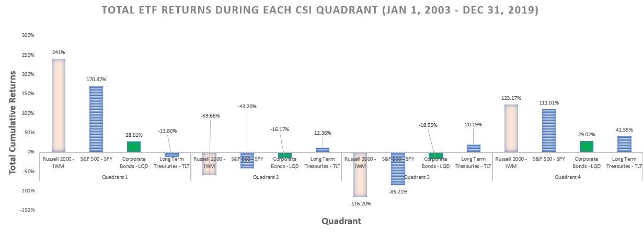

^^^ I think it looks pretty bad :/

Ideally each Quadrant will have its respective four bars closer together. The example I’m showing above just looks like 16 individual bars being graphed… but I’d prefer if the graph puts emphasis on sectioning each quadrant. The below example shows how each cluster’s bars are grouped closer together. I don’t have a preference whether they be actually touching or just closer together.

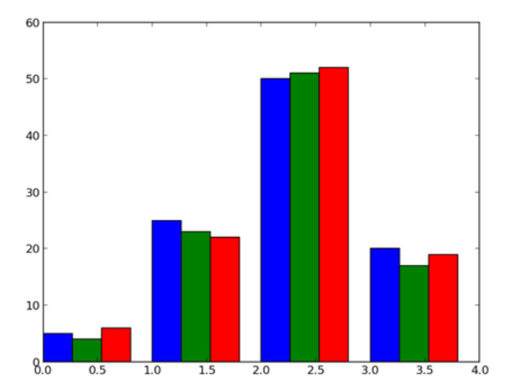

Chart 2 – Four individual charts

My understanding is that matplotlib allows a figure to be generated that has multiple “plots”… similar to the below:

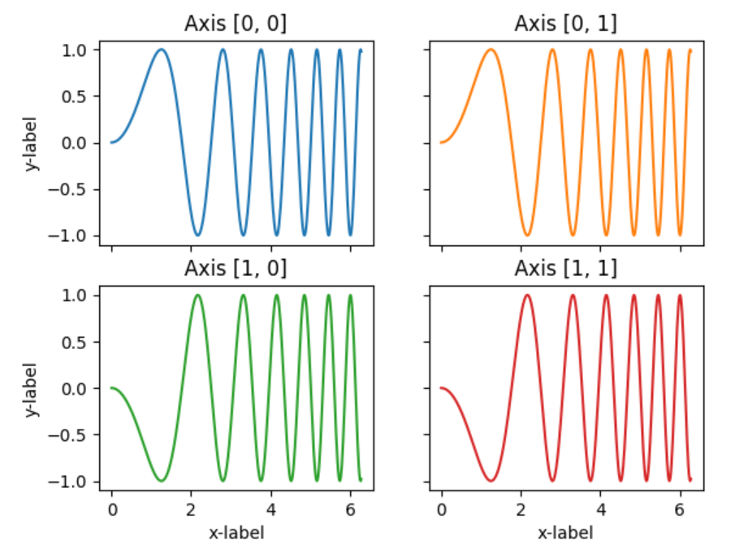

I tried recreating this myself in excel using my own data… the below example is as far as I got.

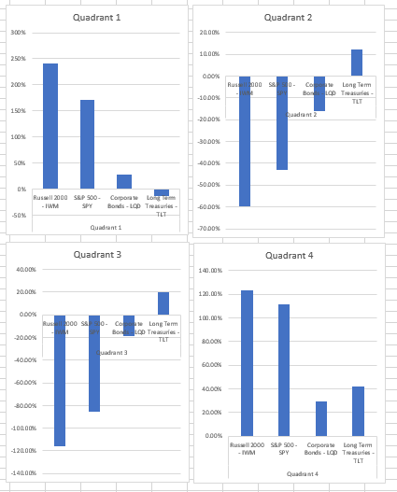

Can a figure be generated that has four plots… where each plot is actually graphing one Quadrant’s data?